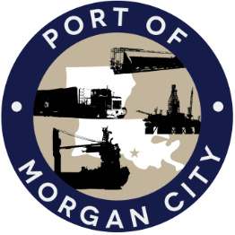

AGENDA

MORGAN CITY HARBOR AND TERMINAL DISTRICT
Regular Meeting of April 9, 2018 – 5:00 p.m. – 7327 Highway 182

1. Call to Order and Roll Call

2. Invocation and Pledge of Allegiance

3. Minutes
A. Regular Meeting of March 12, 2018

4. Finance Report
A. Presentation and discussion of financial reports for March 2018 – Deborah Garber
B. Invoices

5. Guest(s)/Public Comment
A. United States Coast Guard
B. Corps of Engineers, New Orleans District
C. Catherine Holcomb and Monica Mancuso – Support for Urban Land Institute Technical Assistance

6. Raymond “Mac” Wade - Executive Director’s Report
A. Consultant – Michael Knobloch, Knobloch Professional Services, LLC
B. Consultant – Clay Breaud, Providence/GSE
C. Consultant – Michael Lowe, GIS Engineering, LLC
D. Cindy Cutrera, Manager of Economic Development

7. Gerard Bourgeois - Legal Report

8. New Business

9. Old Business
A. Discussion and any action on leasing, improvements, maintenance and repairs to facility(ies), including Coast Guard lease(s) and bids for HVAC work
B. Discussion and any action regarding the U.S. Department of Homeland Security grant program, including request for proposals, bids, purchases, project management, generators, computer data system and NOAA ports system(s)
C. Discussion and any action on Government Operations and Emergency Center including bids, purchases, payments, leasing and Facility Planning and Control
D. Discussion and any action on Atchafalaya River Channel including dredging and sediment management, equipment purchases, reports, survey services, consulting services, economic study(ies), landowner agreements, cooperative agreements with Brice Civil Contractors and the U.S. Army Corps of Engineers
E. Discussion and any action on extension of Sublease with Baker Hughes Oilfield Operations LLC, and related leases

10. Adjournment

In accordance with the Americans with Disabilities Act, if you need special assistance, please contact Tori Henry at 985-384-0850, describing the assistance that is necessary.

